

Candidate Information Booklet

**Administrative Officer –**

**Various Departments**

**Reference No: 07/2025**

**Date: April 2025**

**About the Police Ombudsman for Northern Ireland**

Established under the Police (Northern Ireland) Act 1998, we exist toprovide an independent and impartial police complaints system for the people of Northern Ireland. We receive and investigate complaints about the police made by members of the public, and also matters of public interest involving the Police Service of Northern Ireland (PSNI).

The Police Ombudsman for Northern Ireland is appointed under Royal Warrant and is a corporation sole. Her statutory duty is to exercise her powers in such manner and to such extent as appears to her best calculated to secure the efficiency, effectiveness and independence of the police complaints system, and the confidence of the public and members of the police force in that system. She has responsibility for the Police Service of Northern Ireland (PSNI), ‘designated civilians’ working with the PSNI, Belfast Harbour Police, Belfast International Airport Police and the Ministry of Defence Police.

The Police Ombudsman is also empowered in certain circumstances to investigate the conduct of members of the RUC.Where appropriate she makes recommendations regarding criminal and misconduct matters, in respect of which she may also publish statements and make policy recommendations. In addition to this she has a power to investigate current police policy and practice, and to publish the results of any such investigation. She provides extensive statistical and management information to the Department of Justice, Chief Constable and Northern Ireland Policing Board. In undertaking her statutory duties, the Police Ombudsman employs approximately 150 staff in a number of specialist and support roles. The budget for the Office is around £9m.

The RUC (Complaints etc) Regulations 2001 enables the Police Ombudsman to investigate serious legacy matters.

Further information about the organisation can be found at [www.policeombudsman.org](http://www.policeombudsman.org)

**Background to the role of Administrative Officer – Various Departments**

The role of the Administrative Officer is to provide an effective and efficient administrative support service to those within their department, carrying out a range of administrative tasks, including use of computer systems, maintaining good communications with colleagues and reporting any issues to their line manager, as required.

It is within this context that this Administrative Officer role is required.

The appointment will be made by the Police Ombudsman for Northern Ireland acting in accordance with her powers under the Police (Northern Ireland) Act 1998. Staff appointed under the Act will be employees of the Police Ombudsman and are **not** civil servants. The appointment is a permanent contract, although there may be temporary positions available.

The person appointed in addition to the mandatory qualifications listed in the Employee Specification should have proven inter-personal skills and highly developed communication skills across a range of settings.

The appointee should also possess a full understanding of and commitment to the fundamental principles of human rights and a comprehensive understanding of the sensitive social, cultural and political environment within which the work of the Police Ombudsman operates.

Due to the fact that this recruitment campaign is for various posts, vetting will be dictated by the Department within which the post sits. Vetting could be CTC, SC or DV (see Terms and Conditions for further information).

**Please Note – there will be a cap of 100 applications accepted for the positions. Should the number be reached before the closing date of 2nd May 2025, the recruitment competition will be closed.**

**The Employee Specification**

It is essential that the evidence provided by applicants include sufficient details, which clearly demonstrate how they meet all of the **Eligibility Criteria**. This must include reference to specific examples of actions and achievements; it is not sufficient to provide simply a list of duties and responsibilities. Candidates should demonstrate a successful track record in relation to all specified fields.

**Essential Criteria:**

It is essential that, by the closing date for receipt of applications (2nd May 2025) that candidates have:

1. 5 GCSEs at grade A – C/9 – 4 to include Maths and English (or equivalent) or NVQ Level II Administration

**AND**

A minimum of 1 years’ experience working in an administrative role within a Regulatory, Criminal Justice, Human Resources, Finance or Legal environment

**OR**

In the absence of the educational qualifications detailed above, have 2 years’ experience working in an administrative role within a Regulatory, Criminal Justice, Human Resources, Finance or Legal environment.

1. Experience of handling sensitive personal data in line with data protection and in a confidential manner.
2. Excellent IT skills, including use of Microsoft Word, Outlook and Excel.
3. Excellent communication skills.
4. Proven ability to use own initiative.

**The Recruitment Process**

All applications for employment are considered strictly on the basis of merit. Only information contained in the application form will be considered at shortlisting. Additional information received after the closing date will not be considered. Failure to provide sufficient information in support of an application prior to the closing date will not be considered as grounds for an appeal if an applicant is not shortlisted for interview.

Application forms will be reviewed against the Employee Specification by a blended panel.

Successful candidates who meet the essential criteria will be invited to interview. At interview you will be assessed on how your skillset and experience align with the essential and desirable criteria for this role. Should you be unable to attend for interview on the date offered, we will endeavour to be flexible, however you should note that it may not be possible to offer alternative dates.

You are asked to note the timetables provided at the back of this Candidate Information Booklet.

A merit list for any similar posts which may arise may be established after the recruitment exercise has been completed should the Panel identify more appointable candidates than we currently have posts available. The merit list will be held for 12 months.

**Outcome**

If you are successful at interview you will receive a provisional offer, subject to providing two satisfactory references, obtaining the relevant security clearance level and right to work checks. You may also be required to attend for a pre-employment health assessment. A formal offer will then follow. Please do not provide notice to your current employer until you receive a formal offer of employment from PONI.

**Interview Assessment Criteria**

**KEY COMPETENCIES**

In addition to satisfying the above eligibility criteria, applicants will also be expected to display the following qualities and skills at interview:

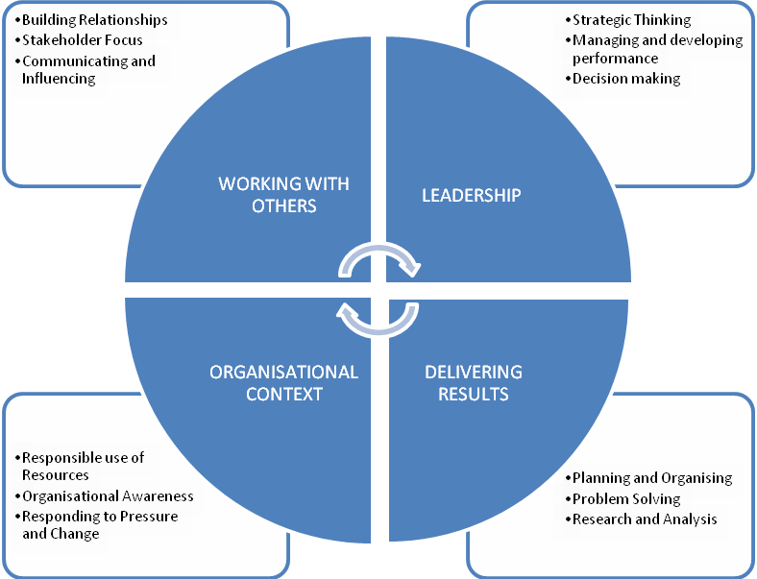

This role falls into the first competency level. The Competency Level Framework document can be found on our website which provides a guide to the behavioural indicators that indicate each competency.

The qualities and skills identified in the personnel specification above are considered essential to the position and will be tested as part of the selection and interview process.

**Canvassing**

Candidates should be aware that any attempts to enlist support for their application through any person except as referee named on the application forms will result in their application being disqualified.

Candidates should be aware that the matter of conflicts of interest will be further explored during the assessment and appointment process.

**Benefits of working for PONI?**

We offer a pleasant, modern hybrid working environment that allows consideration of a range of flexible working arrangements that support a good work/life balance including part-time working options.

As one of our employees, you will enjoy a range of benefits. These include –

* **Flexible Ways of Working** – Hybrid working (60/40 split), term time working, condensed hours and various other ways of working.
* **Family Friendly Policies** – generous maternity, paternity, adoption and shared parental leave above the national minimum standards. We also offer paid special leave of up to a maximum of 10 working days for cases of domestic crisis, or bereavement leave including I the event of a miscarriage or loss of a child.
* **Generous Occupational Sick Pay** – 6 months full pay, 6 months half pay over a rolling four year period.
* **Allowances (where applicable)** – On call allowances, overtime payments, shift disturbance allowance, I.T. allowance.
* **Work/life Balance** – commencing on 25 days annual leave, rising annually 1 day per year for up to 5 years plus 12 bank and public holidays per annum. Access to join the Northern Ireland Civil Service Sports Association where you can avail of many offers and discounts on sports and social activities across Northern Ireland. You will also have the opportunity to apply for the Office’s salary sacrifice Cycle to Work and Childcare Voucher schemes.
* **Employee Support** – access to occupational health services, Employee Assistance Porgramme which includes free and confidential counselling and support programmes, annual flu jab, eye test vouchers, mental health 1st aiders, access to join a private health care provider.
* **Training/Development Opportunities** – opportunities for career and self-development. Access to a range of on-line training sessions and participation in various courses depending on role.

**Terms and Conditions**

**Tenure**

This is a **Permanent** post however temporary posts may become available.

**Remuneration**

The role is equivalent to an Administrative Officer (AO) grade in the Northern Ireland Civil Service grading scale. The salary for the post is in the range £24,225 to £25,732.

Starting salary will be £24,225 with progression in the salary range determined by performance in the post and subject to the review process agreed by the Northern Ireland Civil Service.

**Please note:** two pay awards are pending which would increase the salary to **£24,952 to £26,504** (2024 NICS payscales) and **£26,449 to £28,094** (2025 NICS payscales).

**Security Clearance**

Candidates should be aware that, if successful, they would be required to be vetted to the security clearance level applicable to the post offered. Prior to the final offer of employment, you must successfully complete the vetting process. Vetting is completed by UKSV who provide a recommendation to us. Your application and all supporting information is provided to our Departmental Security Officer (Director of Corporate Services) who reviews the application and makes the final decision, in line with UKSV guidance. UKSV retains your information for a maximum of 15 years after expiration of the vetting clearance. You can read their Privacy Notice on their website for more information. We retain your vetting application information until a final decision is made, then the information is securely destroyed. You can view our Privacy Notice and Retention and Disposal Schedule on our website for more detailed information.

**Hours of Work**

The standard working week is 37 hours excluding meal breaks and the Office does operate a Flexible Working Scheme (FWS). Occasional evening or weekend working may be required in line with business needs.

**Probation**

The probationary period for this post is 12 months. Successful applicants must be prepared to attend professional development courses as directed.

**Annual Leave**

In addition to the usual public and privilege holidays, appointees will receive 25 days annual leave per annum on appointment. The leave year runs from 1 February to 31 January. Successful candidates commencing employment during the leave year will receive a pro-rated leave entitlement.

**Superannuation**

The Office of the Police Ombudsman for Northern Ireland participates in the Principal Civil Service Pension Scheme (NI), which for new entrants starting from 1 April 2015 offers two types of pension choices:

**Alpha** – This is an occupational pension scheme that currently has a member contribution rate relating to salary (currently 7.35 % in the salary range). As your employer we meet the rest of the cost of the scheme.

**Partnership** – This is a stakeholder pension with a contribution from PONI. How much we pay is based on the appointee’s age and we pay this regardless of whether the appointee chooses to contribute anything. Appointee contributions are not compulsory but, if they occur, we as your employer will also match the appointee’s contributions up to 3% of their pensionable earnings. These contributions are in addition to the age related contribution mentioned above.

**Notice**

**Staff at Staff Officer and Above:**

The notice you are entitled to receive and are required to give in the event of your termination of employment is as follows:

Less than one year’s continuous service – one month notice

One year continuous service or more – three months’ notice

**Other Grades**

The notice you are required to give in the event of your termination of employment is one month;

The notice you are entitled to receive in the event of termination of your employment is as follows:

* Less than 4 years’ continuous service – one month’s notice.
* 4 years’ continuous service or more – one week for each year of service up to a maximum of 12 weeks’ notice.

In certain circumstances consideration may be given to a shorter period of notice depending on the merits of each case.

The Ombudsman reserves the right, in the case of gross misconduct, to dismiss you summarily i.e., without notice and without payment in lieu of notice.

**Retirement Age**

Staff may, subject to normal efficiency and attendance requirements, elect to retire at any age from age 60. In line with the Employment Equality (Repeal of Retirement Age Provisions) (Northern Ireland) 2011 there is no compulsory retirement age.

**Applications**

Under Fair Employment legislation, the Police Ombudsman is required to monitor the community background of those applying to fill vacancies. Applicants should therefore complete the application form and return it together with the Equal Opportunities Monitoring Form.

The Police Ombudsman for Northern Ireland is committed to equality of opportunity in employment and welcomes applications from suitably qualified candidates irrespective of disability, gender, race, religious belief, political opinion or sexual orientation. All applications for employment are considered on the basis of merit.

**Guaranteed interview scheme**

We guarantee to interview anyone with a disability whose application meets the minimum criteria for the post. By ‘minimum criteria’ we mean that you must provide us with evidence in your application form which demonstrates that you generally meet the level of competence required for each competency, as well as meeting any of the qualifications, skills or experience defined as essential. The Office of the Police Ombudsman is committed to the employment and career development of disabled people (the minimum criteria means the essential competences as set out in the advertisement for the post).

**What do we mean by disability?**

The Disability Discrimination Act 1995, defines a disabled person as someone who has a physical or mental impairment which has a substantial and adverse long-term effect on his or her ability to carry out normal day-to-day activities.

**How do I apply?**

If you want to apply under the Guaranteed Interview Scheme simply complete Section 4 within the application form.

**How to apply**

To apply for this role, please **complete and submit the application form**.

**Please note that CVs cannot be accepted as part of your application**

The closing date for receipt of completed applications is 4.00pm on Friday 2nd May 2025.

If you have any queries about any aspect of the appointment process or need additional information please contact the Human Resources Department on 028 90 828632.

**Recruitment timetable**

|  |  |
| --- | --- |
| Closing date | **Friday 2nd May 2025 at 4 pm** |
| Shortlist meeting  Interview dates | w/c: **5th May** **2025 (TBC)**  w/c: **19th May 2025 TBC** |
| Anticipated start date | Subject to Security Clearance and Notice Periods. |

Please note – Dates may be subject to change. Should this occur we will strive to give as much notice as possible depending on the circumstances.